**A STUDY ON RELATIONSHIP BETWEEN IT INFRASTRUCTURE & EMPLOYEE ENGAGEMENT - THE ROLE OF HRIS MEDIATION**

*Dissertation submitted in partial fulfillment of the requirements*

*for the award of Degree of*

**MASTER OF BUSINESS ADMINISTRATION**

**With**

**BUSINESS ANALYTICS**

*Submitted by*

**Mukthapuram Sai Swathi (22104E010068)**

*Under the Guidance of*

**Dr. G. Yamuna,** Ph.D.

Assistant Professor, Dept. of Management



**DEPARTMENT OF MANAGEMENT**

**SCHOOL OF COMMERCE & MANAGEMENT**

**MOHAN BABU UNIVERSITY**

Sree Sainath Nagar, Tirupati – 517 102

**(2024)**

** MOHAN BABU UNIVERSITY**

**Vision**

To be a globally respected institution with an innovative and entrepreneurial culture that offers transformative education to advance sustainability and societal good.

**Mission**

* Develop industry-focused professionals with a global perspective.
* Offer academic programs that provide transformative learning experience founded on the spirit of curiosity, innovation, and integrity.
* Create confluence of research, innovation, and ideation to bring about sustainable and socially relevant enterprises.
* Uphold high standards of professional ethics leading to harmonious relationship with environment and society.

**DEPARTMENT OF MANAGEMENT**

**Vision**

To become the Centre of excellence for management education and research in the country, wherein learners are empowered with the advanced management knowledge to effectively utilize their potential in their career and as entrepreneurs for betterment of the society.

**Mission**

* To provide management knowledge to instill the spirit of curiosity, compassion, courage and commitment through effective teaching learning process.
* To uphold the leadership excellence among the learners through research and mentoring.
* To create an effective learning environment that empowers the learners with the right blend of skills with theory and practice to build a dynamic society.

**M.B.A. – Master of Business Administration with Specialization in Business Analytics**

**PROGRAM EDUCATIONAL OBJECTIVES**

|  |  |
| --- | --- |
| **PEO1.** | Pursue higher education in the field of management in functional areas -Marketing, Finance and Human Resources and, Business Analytics, Digital Transformation, International business, Logistics and supply chain management or any other areas of their interest. |
| **PEO2.** | Solve key challenges of management in general and functional areas in particular through a professional career in industry/teaching/research. |
| **PEO3.** | Get inspiration to engage in an entrepreneurial career. |
| **PEO4.** | Manage teams through effective leadership skills. |
| **PEO5.** | Exhibit societal consciousness and ethical behavior in practicing management along with learnability. |

**PROGRAM OUTCOMES**

On successful completion of the Program, the graduates of M.B.A. with specialization in Business Analytics will be able to:

|  |  |
| --- | --- |
| **PO1.** | Gain the knowledge of management concepts relevant to corporate issues. |
| **PO2.** | Analyze the real time problems of the contemporary management. |
| **PO3.** | Develop solutions to the contemporary management challenges. |
| **PO4.** | Interpret the emerging issues in management through proper investigations and analysis. |
| **PO5.** | Utilize appropriate tools and techniques to solve managerial problems. |
| **PO6.** | Provide solutions for managerial problems with social consciousness. |
| **PO7.** | Offer sustainable and environmental friendly strategies in solving managerial issues. |
| **PO8.** | Establish highly ethical and moral standards in the given environment in solving managerial challenges. |
| **PO9.** | Lead the people and work with teams for acceptable outcomes. |
| **PO10.** | Communicate effectively in all forms to the stakeholders. |
| **PO11.** | Manage businesses effectively in a given environment. |
| **PO12.** | Learn continuously on the contemporary issues and practice in the field of management. |

**PROGRAM SPECIFIC OUTCOMES**

On successful completion of the Program, the graduates of M.B.A. with specialization in Business Analytics will be able to:

|  |  |
| --- | --- |
| **PSO1.** | Use fundamental knowledge of management domains to solve complex business problems. |
| **PSO2.** | Use simulated problems, case analysis, projects, and industrial training to gain multidisciplinary knowledge. |
| **PSO3.** | Make competent management professionals through life-long learning who are ethically sound and have an understanding of societal and ecological issues relevant to their profession. |

 **MOHAN BABU UNIVERSITY**

Sree Sainath Nagar, Tirupati 517 102

**SCHOOL OF COMMERCE AND MANAGEMENT**

**DEPARTMENT OF MANAGEMENT**

Certificate

This is to certify that the project report entitled **“A study on relationship between IT infrastructure & employee engagement - the role of HRIS mediation”** is the bonafide work carried out and submitted by **MUKTHAPURAM SAI SWATHI & 22104E010068.** in the Department of **Management, School of Commerce and Management** of **Mohan Babu University**, Tirupati in partial fulfillment of the requirements for the award of the degree of **Master of Business Administration** during 2023-24.

**GUIDE Head, Dept.**

**Dr. G. Yamuna, Ph.D. Dr. M. Naresh Babu, Ph.D.**

Assistant Professor, Dept of Management Associate Professor, Dept of Management

**Date:**

**INTERNAL EXAMINER EXTERNAL EXAMINER**

**ACKNOWLEDGEMENT**

I am pleased to acknowledge my sincere thanks to the **SCHOOL OF COMMERCE AND MANAGEMENT, MOHAN BABU UNIVERSITY** for their kind encouragement in doing this project and for completing it successfully.

I am grateful to them. I convey my thanks to **Dr. M. NARESH BABU Ph.D.,** Head of the Department, Dept. of Management Studies for providing me necessary support and details at the right time during the progressive reviews.

I would like to express my sincere and deep sense of gratitude to my Project Guide **Dr. G. YAMUNA**, **Ph.D.** for her valuable guidance, suggestions and constant encouragement paved the way for the successful completion of my project work.

I wish to express my thanks to all Teaching and Non-teaching staff members of the Department of Business Administration who were helpful in many ways for the completion of the project.

**MUKTHAPURAM SAI SWATHI**

**Roll No: 22104E010068**

**ABSTRACT**

The Human Resource Information System (HRIS) stands at the intersection of human resources and information technology, revolutionizing the management of HR activities within organizations. This paper explores the transformative role of HRIS in enhancing employee retention and fostering the development of robust IT infrastructure. HRIS serves as a comprehensive solution for streamlining HR processes, from data entry to tracking and information management. By consolidating various HR functions such as payroll, labour productivity, and benefit management, HRIS offers a cost-effective alternative to traditional mainframe systems, facilitating more efficient planning, control, and management of HR costs. Moreover, HRIS empowers organizations to make informed decisions, driving improved efficiency and quality in HR decision-making processes. Through enhanced data analytics and reporting capabilities, HRIS enables HR professionals to gain deeper insights into workforce dynamics, thereby optimizing employee engagement strategies and fostering a culture of continuous development. Furthermore, HRIS plays a pivotal role in bolstering employee retention efforts. By providing a seamless and user-friendly interface for accessing HR-related information and services, HRIS enhances employee satisfaction and engagement. Additionally, by automating routine HR tasks and workflows, HRIS frees up valuable time for HR professionals to focus on strategic initiatives aimed at talent development and retention. In tandem with its impact on employee retention, HRIS also contributes to the development of IT infrastructure within organizations. By leveraging cloud-based technology and scalable architecture, HRIS enables seamless integration with existing IT systems, driving efficiency and agility in IT operations. Furthermore, by facilitating the digitization of HR processes, HRIS catalyses the evolution of IT infrastructure towards a more modern and resilient framework.

Key words**:** HRIS, HRM, HRMS, Human Resource, Human Resource Information system

**TABLE OF CONTENTS**

|  |  |  |
| --- | --- | --- |
| **Chapter No.** | **Title** | **Page No** |
|  | **ABSTRACT** | VII |
|  | **TABLE OF CONTENTS** | VIII |
|  | **LIST OF TABLES** | IX |
|  | **LIST OF CHARTS** | X |
|  | **LIST OF FIGURES** | X |
| **1** | **INTRODUCTION** | 1-3 |
|  | 1.1 Introduction about the study | 1-2 |
|  | 1.2 Need of the study | 2-3 |
|  | 1.3 Objectives of the study | 3-4 |
|  | 1.4 Scope of the study | 4 |
|  | 1.5 Limitations of the study | 4 |
| **2** | **LITERATURE REVIEW** | 6 |
|  | 2.1 Literature review of the study | 6-8 |
| **3** | **RESEARCH METHODOLOGY & DESIGN** | 8-11 |
|  | 3.1 Research Methodology | 8 |
|  | 3.2 Research Design | 9 |
|  | 3.3 Research population | 9 |
|  | 3.4 Sample size | 10 |
|  | 3.5 Analytical tools | 10 |
|  | 3.6 Questionnaire Design | 10 |
|  | 3.7 Period of the study | 11 |
| **4** | **DATA ANALYSIS AND INTERPRETATION** | 12-36 |
|  | 4.1 Frequencies table analysis | 12-29 |
|  | 4.2 Inter item correlation | 30-32 |
|  | 4.3 Descriptive statistics | 33 |
|  | 4.4 Linear regression | 34-35 |
|  | 4.5 Hypothesis | 35-36 |
| **5** | **FINDINGS, RECOMMANDATIONS & CONCLUSION** | 37-40 |
|  | 5.1 Findings of the study | 37 |
|  | 5.2 Recommendations & Suggestions | 37-38 |
|  | 5.3 Conclusions | 39 |
|  | **REFERENCES** | 40 |
|  | **APPENDIXI(QUESTIONNAIRE)** | 41-45 |
|  | **PLAGARISIM REPORT** | 46-49 |
|  | **STUDENT -BIODATA** | 50 |
|  | **PO’S MAPPING** | 51 |

**LIST OF TABLES**

|  |  |  |
| --- | --- | --- |
| **TABLE .NO** | **PARTICURS** | **PAGE NO.** |
|  | **FREQUENCIES TABLE ANALYSIS** | 12-29 |
| 4.1 | Gender of respondents | 12 |
| 4.2 | Age of respondents | 13 |
| 4.3 | Experience of respondents | 14 |
| 4.4 | Company profile of respondents | 15 |
| 4.5 | Role of respondents | 16 |
| 4.6 | Aware of HRIS in respondents | 17 |
| 4.7 | HRIS Tool Usage of respondents | 18 |
| 4.8 | Years Software installed by respondents | 19 |
| 4.9 | HRIS Decreased data input expenses of respondents | 20 |
| 4.10 | Job Satisfaction of respondents | 21 |
| 4.11 | Frequencies of HRIS interaction | 22 |
| 4.12 | Frequencies of Employee Retention Factors | 23 |
| 4.13 | Frequencies of Satisfaction level of HRIS | 24 |
| 4.14 | Frequencies of HRIS Enhance Employee Retention Factors | 25 |
| 4.15 | Frequencies of HRIS Training | 26 |
| 4.16 | Frequencies of HRIS Challenges | 27 |
| 4.17 | HRIS Role in Employee retention in IT Sector | 28 |
| 4.18 | HRIS User-friendly Interface | 29 |
| 4.19 | Inter item correlation of Variables | 30 |
| 4.19.1 | The correlation between the HRIS Benefits | 31 |
| 4.19.2 | The correlation between the Reliability factors of HRIS | 31 |
| 4.19.3 | The correlation between the Employee Retention factors of HRIS | 32 |
|  | **DESCRIPTIVE STATISTICS** |  |
| 4.20 | Descriptive statistics of Variables | 33 |
|  | **LINEAR REGRESSION** |  |
| 4.21 | Linear regression analysis | 34 |
|  | **Hypothesis** |  |
| 4.22 | Hypothesis Conclusion table | 36 |

**LIST OF CHARTS**

|  |  |  |
| --- | --- | --- |
| **CHART NO** | **PARTICULARS** | **PAGE NO** |
| 4.1 | Gender of respondents | 12 |
| 4.2 | Age of respondents | 13 |
| 4.3 | Experience of respondents | 14 |
| 4.4 | Company profile of respondents | 15 |
| 4.5 | Role of respondents | 16 |
| 4.6 | Aware of HRIS in respondents | 17 |
| 4.7 | HRIS Tool Usage of respondents | 18 |
| 4.8 | Years Software installed by respondents | 19 |
| 4.9 | HRIS Decreased data input expenses of respondents | 20 |
| 4.10 | Job Satisfaction of respondents | 21 |
| 4.11 | Frequencies of HRIS interaction | 22 |
| 4.12 | Frequencies of Employee Retention Factors | 23 |
| 4.13 | Frequencies of Satisfaction level of HRIS | 24 |
| 4.14 | Frequencies of HRIS Enhance Employee Retention Factors | 25 |
| 4.15 | Frequencies of HRIS Training | 26 |
| 4.16 | Frequencies of HRIS Challenges | 27 |
| 4.17 | HRIS Role in Employee retention in IT Sector | 28 |
| 4.18 | HRIS User-friendly Interface | 29 |

**LIST OF FIGURES**

|  |  |  |
| --- | --- | --- |
| **FIGURE NO** | **PARTICULARS** | **PAGE NO** |
| 4.22 | Conceptual model | 35 |

**CHAPTER :1**

**INTRODUCTION**

**1.1 HUMAN RESOURCE INFORMATION SYSTEMS**

Companies now understand that HR's role has changed from being a fundamental administrative task to a crucial managerial one. Data and information about human resources are being streamlined into transaction procedures so that different stakeholders—including government agencies, employees, and line managers—can easily access them. This change has removed the requirement for multiple roles devoted to HR duties and resulted in a significant reduction in the amount of time spent on basic administrative tasks.

HR managers need thorough data and knowledge on every facet of HRM. The data provided by Human Resource Information Systems (HRIS) is essential for planning, decision-making, control, and reporting. Computer use has significantly streamlined processes like data retention and pay check preparation, which has made analyzing massive amounts of data much easier. The HRIS manager must comprehend the significance and benefits of record-keeping and reporting before developing an HRIS.

HR activities are integrated with IT through Human Resource Management Systems (HRMS) or HR Technology, which sit at the nexus of HRM and IT. These systems, which are frequently included in enterprise resource planning (ERP) software, combine the financial and HR modules by combining data from multiple apps into a single database. Although this integration allows for both flexibility and rigidity, it also necessitates careful construction and planning.

Teams are entrusted with transferring historical data from current HR databases and integrating the new HRIS with other systems during the HRIS deployment process. They frequently run into issues with inconsistent or incomplete data in the current systems, which calls for extensive data validation and cleansing procedures

**1.2 ROLE OF HRIS IN INFORMATION TECHNOLOGY:**

HRIS systems are integral to managing HR functions in IT, handling data from personal information to payroll details, ensuring accuracy and compliance. They streamline recruitment by managing job listings, applicant tracking, and onboarding processes efficiently. Performance management features aid in goal setting, evaluations, and talent development. Benefits administration is simplified through enrolment, coverage changes, and communication with providers. Payroll processing is automated, reducing errors and streamlining tasks. Compliance tools track HR metrics and generate reports for stakeholders and regulators. Employee self-service portals empower staff to manage their information, requests, and training, alleviating HR's administrative burden. Overall, HRIS systems optimize HR processes, enhance data security, and support talent management and compliance goals.

HRIS platforms offer valuable insights into workforce trends, enabling organizations to make data-driven decisions regarding talent acquisition, retention, and development. Moreover, HRIS systems facilitate seamless integration with other IT systems and technologies, such as enterprise resource planning (ERP) software and collaboration tools, enhancing cross-functional collaboration and communication within the organization. Additionally, HRIS platforms support the implementation of emerging technologies, such as artificial intelligence (AI) and machine learning (ML), in HR processes, further advancing the digital transformation agenda of IT departments. In essence, HRIS serves as a linchpin in aligning HR strategies with broader IT objectives, driving organizational agility and competitiveness in the digital age.

**1.3 ROLE OF HRIS IN EMPLOYEE RETENTION:**

HRIS, as a pivotal tool in employee retention strategies, leverages various mechanisms to ensure organizational success and satisfaction among staff. Through robust data analysis capabilities, it aids in understanding employee sentiments, performance trends, and turnover factors, empowering proactive interventions. Facilitating feedback loops and surveys, HRIS cultivates a culture of transparency, allowing organizations to address concerns promptly and refine retention strategies. Efficient performance management via HRIS fosters a culture of recognition and growth, incentivizing top performers and providing avenues for skill enhancement and career progression. Furthermore, by tracking training needs and facilitating access to learning resources, HRIS nurtures employee development, enhancing their loyalty and commitment to the organization.

Streamlining benefits administration processes, HRIS ensures seamless access to and management of employee benefits, contributing significantly to their satisfaction and overall retention. Additionally, by supporting flexible work arrangements and enabling work-life balance, HRIS accommodates diverse employee needs, further bolstering retention efforts.

Finally, through succession planning initiatives, HRIS identifies and grooms future leaders within the organization, offering clear career paths and advancement opportunities. In essence, HRIS serves as a cornerstone in fostering a positive work environment, driving employee engagement, and ultimately enhancing retention rates.

**1.4 Harmonizing HRIS Advancements with IT Infrastructure for Enhanced Employee Retention:**

Innovative approaches leveraging HRIS and IT infrastructure are transforming the employee experience within organizations. By incorporating gamification elements, routine HR tasks become more engaging, motivating employees to participate actively. Virtual reality (VR) training offers immersive learning experiences, while AI-powered chatbots provide personalized support, enhancing accessibility to HR services. Augmented reality (AR) onboarding creates memorable introductions for new hires, fostering early engagement and familiarity with the company culture. Blockchain-based recognition platforms securely record and reward employee achievements, while predictive analytics anticipate engagement levels and guide proactive interventions. Virtual team-building activities promote collaboration and camaraderie among remote teams, leveraging IT infrastructure to bridge geographical barriers. These innovative approaches not only enhance employee engagement but also foster continuous learning and development, ultimately cultivating a positive and dynamic work culture within organizations.

**1.5 ROLE OF HRIS TOOLS AND THEIR CONTRIBUTION:**

These famous HRIS tools contribute to organizational success by enabling HR departments to streamline processes, improve efficiency, enhance employee engagement, and make data-driven decisions that drive business growth and competitiveness. Workday, SAP SuccessFactors, Oracle HCM Cloud, ADP Workforce Now, and UltiPro are renowned HRIS platforms, each offering unique solutions to streamline HR functions. Workday, a cloud-based platform, excels in managing complex HR processes for large enterprises, including recruitment and benefits administration, thanks to its user-friendly interface and robust analytics. SuccessFactors, part of the SAP suite, caters to multinational corporations with its scalability and compliance features, aligning HR processes with business objectives. Oracle HCM Cloud stands out for its flexibility and deep integration with Oracle's suite of applications, empowering HR teams with actionable insights through advanced analytics. ADP Workforce Now simplifies HR and payroll administration for mid-sized businesses, ensuring compliance and providing tools for effective workforce management. UltiPro focuses on the entire employee lifecycle, supporting recruitment to retirement with its comprehensive feature set and personalized employee experiences. These HRIS tools contribute significantly to organizational success by streamlining processes, enhancing efficiency, and driving employee engagement through data-driven decision-making. BambooHR is popular among small to medium-sized businesses, offering tailored HRIS solutions with features like employee management and performance tracking. Kronos Workforce Ready targets mid-sized businesses with HR, payroll, and scheduling functionalities, emphasizing workforce management and compliance. PeopleSoft, now part of Oracle, provides scalable modules for core HR, payroll, and talent management, catering to large enterprises. Ceridian Dayforce integrates HR, payroll, and talent management seamlessly, empowering real-time decision-making with analytics. Namely offers an all-in-one solution for mid-sized companies with modern interface and self-service capabilities. Zenefits simplifies HR processes for small businesses, focusing on onboarding, benefits administration, and compliance management. These HRIS platforms streamline processes, improve efficiency, and enhance employee engagement, driving organizational success in today's competitive landscape.

**1.6 NEED OF THE STUDY:**

* HRIS serves as a centralized platform for storing and managing individual employee
* information, facilitating planning, decision-making, and control of HR functions.
* Implementing HRIS brings numerous advantages, including enhanced efficiency, automation, and support for strategic decision-making.
* Centralizing data management through HRIS streamlines processes, reduces redundancy, and boosts operational efficiency.
* Improved data accuracy achieved through HRIS ensures reliable reporting and analytics, enabling organizations to derive meaningful insights for informed decision-making.
* Enhanced reporting capabilities empower HR professionals to analyze trends, identify areas for improvement, and devise strategic initiatives effectively.
* HRIS facilitates employee self-service, allowing staff to autonomously manage their information, which fosters engagement and productivity.
* The efficiencies gained through HRIS implementation result in cost savings as HR processes become more streamlined and less labour-intensive.
* Ultimately, HRIS empowers organizations to leverage data-driven insights for strategic HR decisions, driving growth and competitiveness in today's dynamic business landscape.

**1.7 OBJECTIVES OF THE STUDY:**

* To Understand the role of HRIS in fostering employee engagement in the IT sector.
* To Assess current employee engagement levels and identify influencing factors.
* To Analyse the relationship between employee engagement and HRIS effectiveness.
* To Identify specific HRIS functionalities enhancing employee engagement and supporting management functions.
* To Highlight HRIS's superiority over manual systems in data management and reporting for engagement promotion.
* Evaluate HRIS support for management in addressing emerging opportunities and challenges in the dynamic IT sector landscape.

**1.8 SCOPE OF THE STUDY:**

* Analysing the relationship between employee engagement and HRIS functionality.
* Assessing how HRIS supports efficient management functions through streamlined data management.
* Exploring HRIS's contribution to management decision-making and proactive responses to industry dynamics in the IT sector.
* Investigating HRIS's role in enhancing employee engagement in the IT sector.

**1.9** **LIMITATIONS OF THE STUDY:**

* The timeframe allocated for the study is constrained.
* The study's results may not reflect the actual outcomes due to the limited sample size of 110.
* The analysis relies on certain statistical tools, each with its inherent limitations

**CHAPTER-2**

**REVIEW OF LITERATURE**

Mohamed Alkashami (2023)Stated in his paper **“**The Necessity of HRIS in the Contemporary Era: A Detailed Exploration” it offers insight into HRIS in the contemporary era, detailing the heightened organizational focus on its necessity. It discusses key features of HRIS and its significance for HR functions. Additionally, it addresses HRIS market growth, design, and development, along with their applicability. Towards the end, the paper delves into challenges and barriers to effective HRIS implementation in the 21st century.Sukanto Krisbianto (2023) Stated in his paper **“**Impact of HR Information Systems on Employee Performance**”** states that the research aims to ascertain the impact of HR information systems on employee performance. Employing descriptive and verification methods, the study focuses on all employees of the Promenade Bandung hotel. The findings reveal a significant effect of the HR Information System on employee performance, with a notable 57.1% influence observed. The paper suggests that adhering to the Company's Operating Standards can further enhance this influence, highlighting the importance of HRIS in optimizing employee performance.Dr. Muhammad Awais Bhatti (2023) in his Study “Management and IT Support: Key Drivers of HRIS Satisfaction for HR Professionals” he investigates how management and IT support affect HR professionals' satisfaction with HRIS, considering work engagement and effort expectancy. Results from 219 participants show significant contributions of management and IT support to HRIS satisfaction. Work engagement strengthens these relationships, while effort expectancy moderates the effect of management support. Supporting management and IT personnel enhances HR professionals' satisfaction with HRIS, highlighting the importance of user support and work engagement in technology initiatives.

Eddy Hermawan Hasudungan Panjaitan (2023) Stated in his Study “Technological Advancements and HRM Efficiency: Exploring the Role of HRIS”States that Technological advancements drive changes in resource management for competitive edge. HRIS implementation is pivotal for efficiency in HRM. This study explores HRIS impact on HRM efficiency. Analysis shows HRIS enhances effectiveness across HR functions. Findings highlight HRIS as crucial for organizational competitiveness.Mareyza, A. R., & Sumartik. (2023) Stated in his Study of “Assessing the Impact of HRIS on Employee Performance, Career Development, and Organizational Commitment: The Mediating Role of Motivation” This paper states that it aims to assess the impact of HRIS, career development, and organizational commitment on employee performance, with motivation as a mediator. Data from 147 employees were analyzed, with 60 selected through simple random sampling. SmartPLS 3.2.8 software facilitated data analysis. Results indicate HRIS significantly affects employee performance, along with career development's impact on motivation. Organizational commitment showed no significant direct effect. Motivation emerged as a pivotal factor influencing employee performance, emphasizing its importance in HR practices optimization.A. Ammupriya, Preetha Subrahmanyan (2022) Stated in his Study of “HRIS Adoption and Work Engagement: The Mediating Role of Workplace Well-being” states that it aims to explore how HRIS adoption enhances work engagement, considering the mediating role of workplace well-being. Using AMOS software, the study employs the CFA method to construct the SEM model. Data from a structured questionnaire, gathered from 300 respondents using a 5-point Likert scale, are analyzed. Results indicate a significant mediating effect of workplace well-being between HRIS adoption and work engagement, emphasizing the importance of well-being in organizational settings.

Sharma, K., Das, M. (2022) Stated in his Study of “Impact of HRIS on Employee Wellness Programs: Insights and Recommendations” examines the impact of Human Resource Information Systems (HRIS) on employee wellness programs within organizations. Through an analysis of relevant research, the review explores how HRIS can support the design, implementation, and evaluation of health and well-being initiatives aimed at improving employee physical, mental, and emotional well-being. It also discusses challenges and opportunities associated with the use of HRIS in employee wellness management and offers recommendations for future research and practice in this area.Rodriguez, J., Martinez, M. (2022) Stated in his Study of “HRIS and Compliance Management: Addressing Regulatory Challenges” examines the role of Human Resource Information Systems (HRIS) in addressing regulatory challenges related to compliance management in organizations. Drawing on a synthesis of relevant research, the review explores how HRIS can help organizations ensure compliance with labour regulations, and industry standards through features such as automated reporting, audit trails, and compliance tracking. It also discusses challenges and best practices associated with the implementation and use of HRIS for compliance management and offers recommendations for practitioners and researchers.Lee, J., Park, H. (2022) Stated in his Study of “HRIS Support for Remote Work Arrangements: Challenges, Opportunities, and Recommendations” They examine the role of Human Resource Information Systems (HRIS) in supporting remote work arrangements within organizations. Through an analysis of relevant research, the review explores how HRIS can help organizations adapt their HR practices and systems to the needs of a distributed workforce, including features such as remote access, virtual collaboration tools, and performance management solutions. It also discusses challenges and opportunities associated with the use of HRIS in remote work settings and offers recommendations for future research and practice.

Chen, Y., Wang, Q. (2022) Stated in his Study of “Leveraging HRIS for Big Data Analytics in HR Decision-Making: Challenges and Opportunities” examine the role of Human Resource Information Systems (HRIS) in harnessing big data for HR decision-making. Through an analysis of relevant research, the review explores how HRIS can help organizations collect, analyze, and interpret large volumes of HR-related data to inform strategic workforce planning, talent management, and organizational decision-making. It also discusses challenges and opportunities associated with the use of HRIS in data analytics and offers recommendations for practitioners and researchers interested in leveraging HRIS for HR decision-making purposes.Nguyen, T., Tran, H. (2022) Stated in his Study of “Evolution of HRIS: From Transactional Systems to Strategic Tools” traces the evolution of Human Resource Information Systems (HRIS) from transactional systems to strategic tools that support organizational decision-making and strategic planning. Through an analysis of historical and contemporary literature, the review explores key developments in HRIS technology and their implications for HR practices. It also discusses emerging trends such as predictive analytics, artificial intelligence, and cloud-based HRIS, and their potential impact on the future of HRIS evolution. The review concludes with recommendations for practitioners and researchers interested in leveraging HRIS for strategic purposes.Dr. Emily Green, Prof. Michael Chen (2021) Stated in her Study of “HRIS Integration in IT Departments: Insights from Multinational Corporations” This study delves into HRIS integration in IT departments through case studies in three multinational corporations. It uncovers the factors contributing to successful integration, such as organizational culture, leadership, and technological infrastructure. The research also highlights the role of HRIS in talent management and workforce analytics, offering actionable insights for IT leaders and HR practitioners aiming to leverage HRIS for competitive advantage.

Dr. Sarah Johnson, (2021) Stated in her Study of “User Acceptance of HRIS in IT Departments: Insights from the UTAUT Model” This empirical study explores user acceptance of HRIS in IT departments, employing the UTAUT model to understand the factors influencing adoption. Findings reveal the significance of perceived usefulness and ease of use in driving HRIS acceptance. Additionally, social influence and facilitating conditions play crucial roles in shaping user attitudes, emphasizing the need for tailored implementation strategies and user training programs.Maamari, B.E. and Osta, A. (2021) Stated in his Study of “Impact of HRIS Implementation Success on Job Involvement, Satisfaction, and Work Engagement in SMEs” in This paper states that it investigates the impact of HRIS implementation success on job involvement, satisfaction, and work engagement in SMEs. Using a quantitative approach, data from 1,082 responses across 163 SMEs are analyzed. Findings reveal HRIS implementation moderately affects job involvement and work engagement but significantly influences job satisfaction. Additionally, a negative correlation is observed between job involvement and HRIS implementation success and job satisfaction**.** Blesa Ibrahim Mohammed (2021) Stated in his Study of **“**HR Management, Organizational Excellence, and Staff Welfare” This paper talks about investigating the relationship between HR management, organizational excellence, and staff welfare in private hospitals in Kurdistan Region, Iraq. Using a quantitative method, data was collected via a questionnaire from 35 respondents. Findings highlight the importance of HRIS in adapting to changes and enhancing decision-making. The study recommends integrating business planning with excellence for organizational success.

**CHAPTER- 3**

**RESEARCH METHODOLOGY**

* 1. **RESEARCH METHODOLOGY:**

The research methodology will employ a mixed-methods approach, combining quantitative analysis of HRIS utilization data with qualitative insights from interviews and surveys conducted among HR professionals and IT personnel. This dual methodology will enable a comprehensive examination of the transformative role of HRIS in both employee retention and IT infrastructure development. Data will be collected from a convenience sample of participants drawn from various IT organizations, ensuring a diverse representation for robust analysis. Statistical techniques and thematic analysis will be utilized to extract meaningful insights, offering a nuanced understanding of the interplay between HRIS, employee retention, and IT infrastructure enhancement.

* 1. **SAMPLE DESIGN:**

The sampling design is the definite plan for obtaining a sample from a given population. It consists of number of items such as sample size, sampling unit, sampling technique, sampling area. In the current research, mostly qualitative primary data collected through online questionnaires with Various employees through questionnaire which is pre coded and pre tested contacts.

**3.2.1 SAMPLING TECHNIQUE:**

The sampling technique used in the project is Convivence Sampling. In this study employing convenience sampling, 110 participants from the IT sector were selected based on accessibility and willingness to participate. The method prioritized practicality in data collection, reflecting real-world constraints. By focusing on IT professionals, the research aimed to explore the interplay between HRIS mediation, IT infrastructure, and employee retention. Though the sampling technique may introduce bias, it facilitated swift data acquisition, allowing for timely analysis. This approach provides valuable insights into optimizing HRIS interventions and enhancing employee retention strategies within IT organizations.

**3.2.2 SAMPLE SIZE:**

The sample size of the research was 110. A total 110 questionnaires were offered to the individuals, 110 questionnaires were received through the google forms.

**3.2.3 PERIOD OF STUDY:**

The study was conducted for three months between DEC 2023- FEB 2024

**3.3 SOURCES OF THE DATA:**

Primary data has been meticulously gathered directly from employees within the Information Technology (IT) sector utilizing a structured questionnaire. This methodological approach underscores a deliberate effort to procure firsthand insights and perspectives from individuals actively engaged in the IT industry. The questionnaire, meticulously designed to encapsulate a comprehensive array of inquiries, serves as a conduit for eliciting detailed responses regarding various facets of their professional experiences, challenges, and perceptions within the dynamic landscape of IT. This tailored approach to data collection underscores a commitment to capturing nuanced insights that may otherwise remain obscured by relying solely on secondary sources or generalized datasets. By engaging directly with employees through this primary data collection method, the study seeks to enrich its understanding of the intricacies, trends, and emerging issues within the IT sector, thereby laying a robust foundation for informed analysis and strategic decision-making

**3.3.1 PRIMARY DATA:**

The primary data was collected through 110 respondents

**3.3.2 QUESTIONNAIRE DESIGN:**

Questionnaire was designed based on existing research papers. This questionnaire is divided as two sections. First section completely covers the demographic data that covers Age, Gender, Occupation, Educational qualification, Location and next section covers about the perception, usage, and impact of Human Resource Information Systems (HRIS) within the IT sector. It encompasses various aspects related to HRIS implementation, employee satisfaction, retention factors, system usability, challenges, and perceived benefits using Likert questions where 1- being strongly disagree, 2 being disagree, 3 being neutral, 4 being agree and 5 being strongly agree.

**3.4 RESEARCH DESIGN:**

The research design for this study entails a descriptive approach aimed at analysing the organization's IT infrastructure, with a specific focus on hardware, software, and network capabilities. Additionally, employee perceptions of the HRIS implementation will be evaluated through a combination of surveys and interviews, aiming to understand its impact on job satisfaction and retention. This comprehensive approach seeks to identify strengths, weaknesses, opportunities, and threats associated with both HRIS and IT infrastructure, providing a holistic view of the organizational landscape. Quantitative analysis will be utilized to interpret and compare data gathered from questionnaires, enabling statistical insights. Furthermore, the research will explore the interconnectedness between HRIS, IT infrastructure, and employee retention through integrated data analysis. Actionable insights derived from the findings will be shared with HR and IT professionals, empowering them to optimize HRIS interventions and refine employee retention strategies. Recommendations stemming from the research outcomes will emphasize leveraging HRIS capabilities to enhance employee satisfaction, engagement, and ultimately, retention. Strategic decisions informed by these findings will aim to align HR and IT objectives, fostering synergy between HRIS implementation and organizational goals.

**3.4.1 RESEARCH POPULATION:**

The research population comprises IT professionals from diverse companies, offering varied perspectives on the impact of HRIS implementation on IT infrastructure and employee retention. Convenience sampling was utilized to select participants from a range of organizational settings within the IT sector, ensuring broad representation for comprehensive analysis. Participants were chosen based on availability and accessibility, facilitating a convenient yet diverse sample composition. This diverse pool of IT professionals will facilitate a nuanced understanding of the complex interplay among HRIS implementation, IT infrastructure optimization, and employee retention strategies. By including individuals from different companies and organizational contexts within the IT sector, the research aims to capture a wide array of experiences and viewpoints, ensuring findings are not confined to a specific subset of professionals but reflective of the broader industry landscape. Insights gathered from these IT professionals via a survey conducted using Google Forms with close-ended questions will provide valuable inputs for developing effective HRIS interventions and employee retention strategies.

* 1. **ANALYTICAL TOOLS:**

Various tables and charts are used as a means for easy representation of data analysed through Percentage Analysis.**3.6 SOFTWARE USED**

Microsoft Excel

SPSS: statistical package for the Social Science

**3.7 PERIOD OF STUDY:**

The study was conducted for three months between DEC 2023- FEB 2024

**3.8 HYPOTHESIS TESTING**

The Hypothesis tested by the following techniques:**3.8.1. REGRESSION**

Regression is a statistical technique used in data analysis to represent the connection between

a dependent variable and one or more independent variables. The purpose of regression

analysis is to understand and predict the value of the dependent variable using the values of

the independent variables. Regression explains how the value of one variable changes as the

value of another changes.

**3.8.2. CORRELATION**

Correlation is a technique to measure the degree to which two or more variables change

together. Simply said, it tells us whether and to what extent one variable is related to another.

If "r" is close to one, it implies a high positive correlation, which means that when one

variable increases, so does the other. If "r" is near to -1, it implies a high negative correlation,

which means that when one variable rises, the other tends to fall. If "r" is near to 0, it suggests

a weak or no association, implying that there

**CHAPTER – 4**

**DATA ANALYSIS AND INTERPRETATION**

**The following are the analysis done during the research study**

**4.1 Gender Profile**

**Table 4.1 Showing Gender of respondents**

|  |  |  |
| --- | --- | --- |
| **Gender** | **No. of Respondents** | **Percentage** |
| Male | 67 | 60.9 |
| Female | 43 | 39.1 |
| **Total** | **110** | **100.0%** |

**Source: Primary Data**

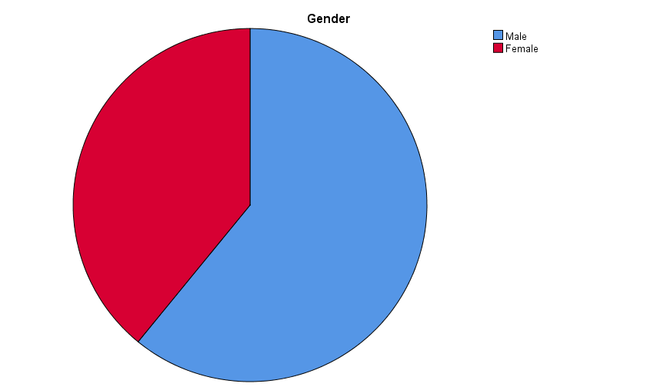

**Chart 4.1 Showing Gender wise Classification of respondents**

**Interpretation.**

From the above Pie chart shows that 60.9% are male respondents and 39.1% are female respondents. Male respondents are High compared to female respondents.

**Inference.**

Most of the respondents are male

**4.2 Age profile**

**Table 4.2 Showing Age wise Classification Of respondents**

|  |  |  |
| --- | --- | --- |
| **Age** | **No. of Respondents** | **Percentage** |
| 21-30 Years | 51 | 46.4% |
| 31- 40 Years | 30 | 27.3% |
| 41-50 Years | 17 | 15.5% |
| Above 50 Years | 1 | 10.0% |
| **Total** | **110** | **100.0%** |

**Source: Primary Data**

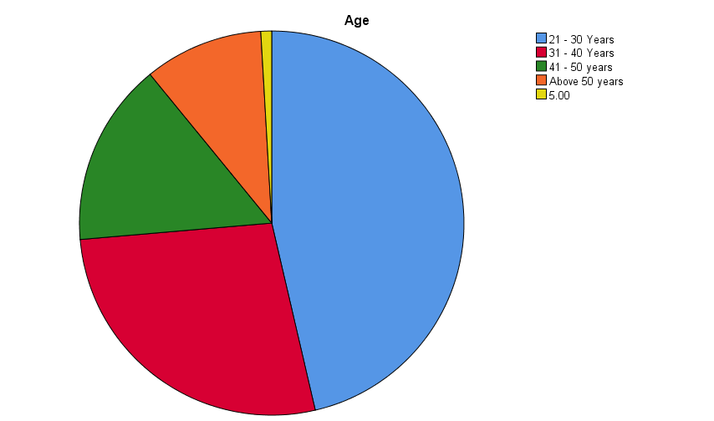

**Chart4.2** Showing Age wise Classification of respondents

**Interpretation:**

From the above table it is interpreted that 46.4% of Respondents are 21-30 Years age group. And 27.3% of the respondents are between 31-40 Years, And 15.5% respondents between 41-50, And 10.0% of Above 50 Years.

**Inference:**

Most of the respondents are 21-30 Years age group.

**4.3 Experience**

**Table 4.3 Showing experience of respondents**

|  |  |  |
| --- | --- | --- |
| **Experience** | **No. of Respondents** | **Percentage** |
| 1-5 Years | 8 | 7.3% |
| 6-10 Years | 51 | 46.4% |
| 11-15 Years | 33 | 30.0% |
| Above 15 Years | 18 | 16.4% |
| **Total** | **110** | **100.0%** |

**Source: Primary Data**

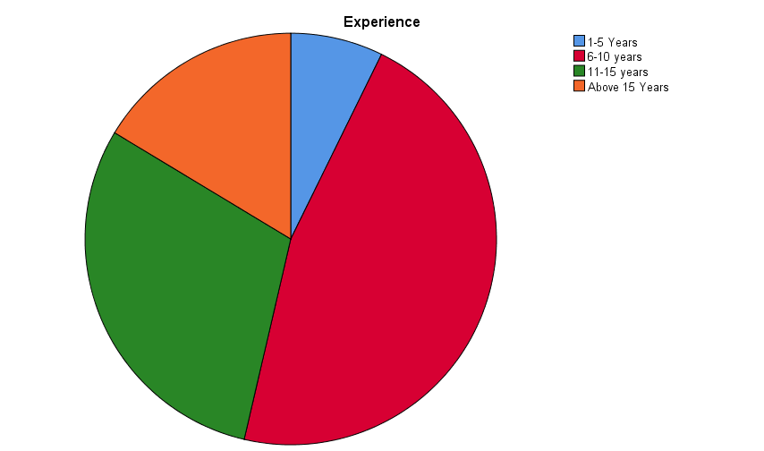

**Chart 4.3 Showing Experience of Respondents**

**Interpretation:**

From the above table it is interpreted that 46.4% of Respondents are 6-10 Years Experience group. And 30.0% of the respondents are between 11-15 Years, And 7.3% respondents between 1-5 Years Experience, And 16.4% of Above 15 Years.

**Inference:**

Most of the respondents are Having Experience between 6-10 Years.

**4.4 Company Profile**

**Table 4.4 Showing Company Profile of Respondents**

|  |  |  |
| --- | --- | --- |
| **Company Name** | **No. of Respondents** | **Percentage** |
| Resource Pro | 25 | 22.7% |
| Infosys | 36 | 32.7% |
| Capgemini | 16 | 14.5% |
| Accenture | 15 | 13.6% |
| Cognizant | 18 | 16.4% |
| **Total** | **110** | **100.0%** |

**Source: Primary Data**

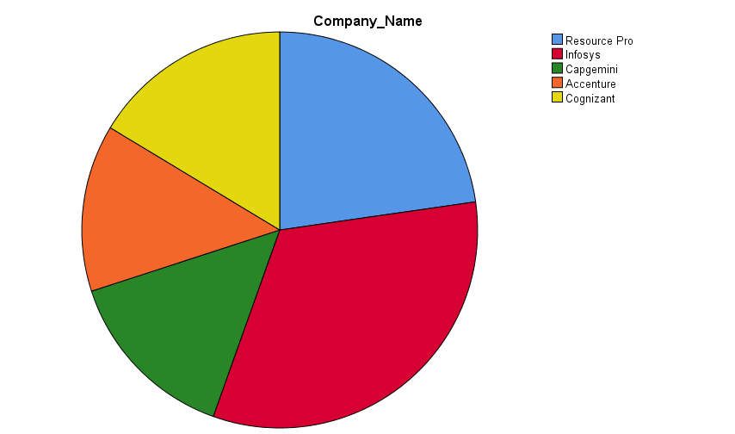

**Chart 4.4 Showing Company Profile of Respondents**

**Interpretation:**

From the above table it is interpreted that the distribution of respondents among different companies. Infosys has the highest percentage of respondents at 32.7%, followed by Resource Pro with 22.7%. Capgemini, Accenture, and Cognizant hold 14.5%, 13.6%, and 16.4% respectively.

**Inference:**

Most of the respondents are from Infosys.

**4.5 Role**

**Table 4.5 Showing Role of Respondents**

|  |  |  |
| --- | --- | --- |
| **Role** | **No. of Respondents** | **Percentage** |
| **Software Developer** | 23 | 20.9% |
| **IT Support Specialist** | 38 | 34.5% |
| **Project Manager** | 12 | 10.9% |
| **Data Analyst** | 17 | 15.5% |
| **Other** | 20 | 18.2% |
| **Total** | **110** | **100.0%** |

**Source: Primary Data**

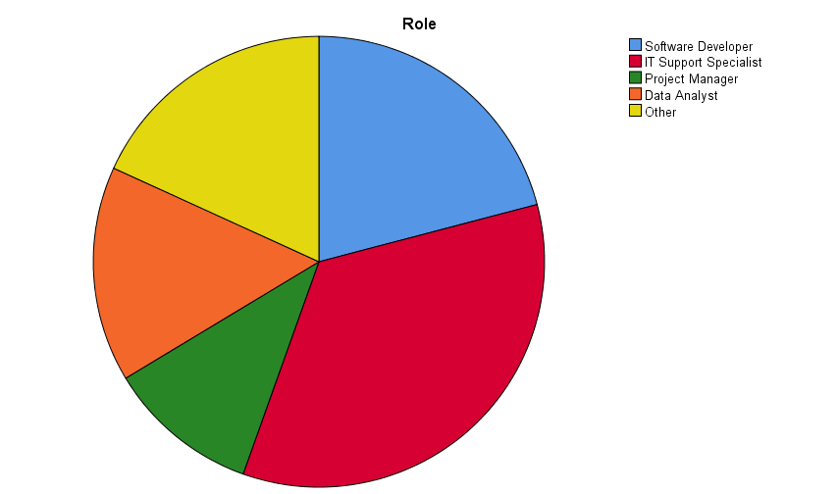

**Chart 4.5 Showing Role of Respondents in Company**

**Interpretation:**

From the above table it is interpreted that This data illustrates the distribution of respondents based on their roles. IT Support Specialists represent the largest portion at 34.5%, followed by Software Developers at 20.9%. Data Analysts, Project Managers, and other roles constitute 15.5%, 10.9%, and 18.2% respectively.

**Inference:**

Most of the respondents are working as IT Support Specialist.

**4.6 Aware of HRIS**

**Table 4.6 Showing Aware of HRIS in Respondents**

|  |  |  |
| --- | --- | --- |
| **Aware of HRIS** | **No. of Respondents** | **Percentage** |
| YES | 110 | 100.0% |
| NO | 0 | 0.0% |
| **Total** | **110** | **100.0%** |

**Source: Primary Data**

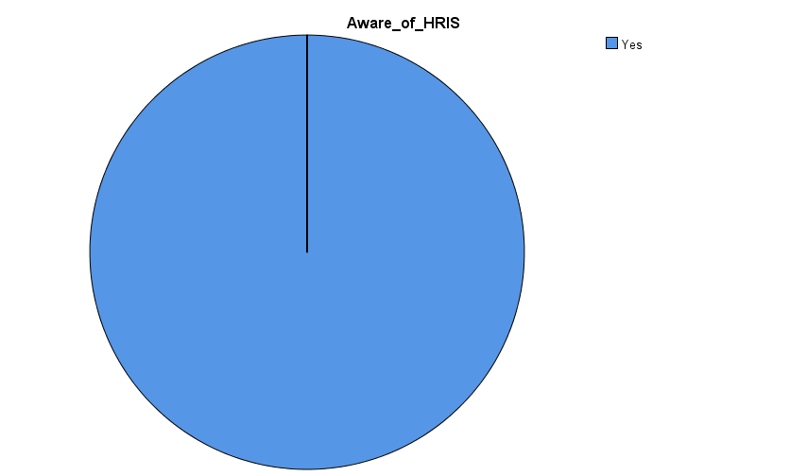

**Chart 4.6 Showing Aware of HRIS in Respondents**

**Interpretation:**

From the above table it is interpreted that All respondents are aware of HRIS (Human Resource Information System), indicating universal familiarity within the surveyed group, with 100% acknowledging its presence.

**Inference:**

All the respondents are aware of HRIS.

**4.7 HRIS Tool**

**Table 4.7 Showing HRIS Tool used by Respondents**

|  |  |  |
| --- | --- | --- |
| **HRIS Tool** | **No. of Respondents** | **Percentage** |
| Workday | 35 | 31.8% |
| ADP Workforce Now | 31 | 28.2% |
| BambooHR | 13 | 11.8% |
| Zenefits | 9 | 8.2% |
| SAP SuccessFactors | 13 | 11.8% |
| Other Tools | 9 | 8.2% |
| **Total** | **110** | **100.0%** |

**Source: Primary Data**

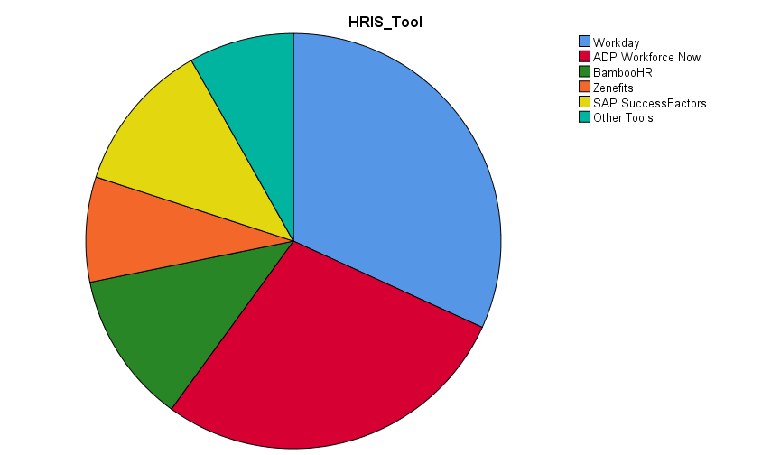

**Chart 4.7 Showing HRIS Tool used by Respondents**

**Interpretation:**

From the above table it is interpreted that Workday and ADP tools Workforce Now are the most popular choices, representing 31.8% and 28.2% respectively. Other notable includes SAP SuccessFactors, BambooHR, and Zenefits, each with shares ranging from 8.2% to 11.8%.

**Inference:**

Most of the respondents use Workday.

**4.8 Years Software Installed**

**Table 4.8 Showing Years Software Installed**

|  |  |  |
| --- | --- | --- |
| **Software Installation** | **No. of Respondents** | **Percentage** |
| 1 Year | 33 | 30.0% |
| 2 Years | 30 | 27.3% |
| 3 Years | 12 | 10.9% |
| 4 Years | 18 | 16.4% |
| More than 5 Years | 17 | 15.5% |
| **Total** | **110** | **100.0%** |

**Source: Primary Data**

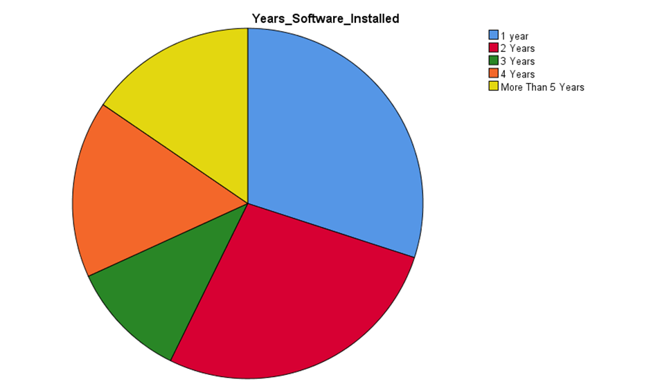

**Chart 4.8 Showing Years Software Installed**

**Interpretation:**

From the above table it is interpreted that data presents the distribution of software installations across various durations. The highest percentage of respondents, 30.0%, installed software within the past year, followed by 27.3% within the last two years. Subsequent percentages are 10.9% for three years, 16.4% for four years, and 15.5% for durations exceeding five years.

**Inference:**

The highest percentage of respondents, 30.0%, installed software within the year.

**4.9 HRIS has decreased data input expenses**

**Table 4.9 Showing HRIS decreased data input expenses**

|  |  |  |
| --- | --- | --- |
| **HRIS Decreased Expenses** | **No. of Respondents** | **Percentage** |
| Strongly Agree | 25 | 22.7% |
| Agree | 45 | 40.9% |
| Strongly Disagree | 12 | 10.9% |
| Disagree | 14 | 12.7% |
| Neutral | 14 | 12.7% |
| **Total** | **110** | **100.0%** |

**Source: Primary Data**

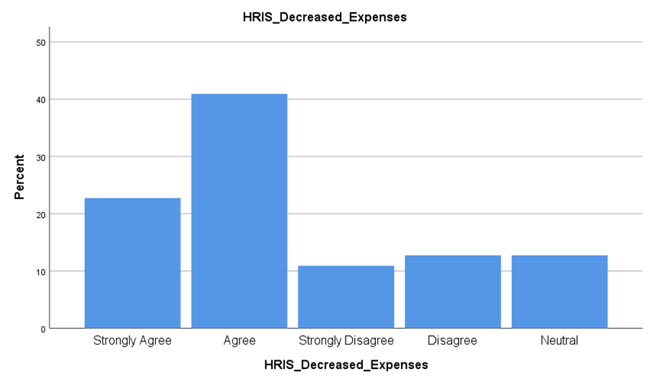

**Chart 4.9 Showing** **HRIS decreased data input expenses**

**Interpretation:**

From the above table it is interpreted that HRIS decreased data input expenses attitudes towards a statement or proposition, with "Agree" being the most common response at 40.9%, closely followed by "Strongly Agree" at 22.7%. Conversely, "Strongly Disagree" and "Disagree" collectively represent 23.6% of responses, while 12.7% remain neutral towards the statement.

**Inference:**

Mostly Respondents proposition with "Agree" being the most common response at 40.9%.

**4.10 Job Satisfaction**

**Table 4.10 Showing Satisfaction of Current Job**

|  |  |  |
| --- | --- | --- |
| **Satisfaction of Current Job** | **No. of Respondents** | **Percentage** |
| Satisfied | 17 | 15.5% |
| Very Satisfied | 38 | 34.5% |
| Neutral | 25 | 22.7% |
| Dissatisfied | 15 | 13.6% |
| Strongly Dissatisfied | 15 | 13.6% |
| **Total** | **110** | **100.0%** |

**Source: Primary Data**

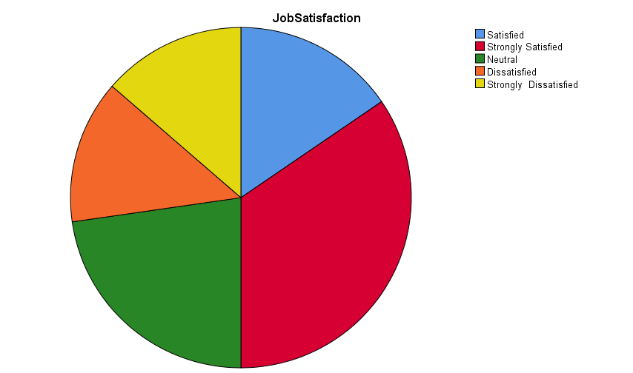

**Chart 4.10 Showing Job Satisfaction of Respondents**

**Interpretation:**

From the above table it is interpreted that the majority of respondents express positive sentiments, with 34.5% being "Very Satisfied" and 15.5% "Satisfied." However, dissatisfaction is also notable, with 13.6% each reporting "Dissatisfied" and "Strongly Dissatisfied," while 22.7% remain neutral.

**Inference:**

The majority of respondents express positive sentiments, with 34.5% being "Very Satisfied”.

**4.11 HRIS Interaction Frequency**

**Table 4.11 Showing HRIS Interaction Frequency**

|  |  |  |
| --- | --- | --- |
| **HRIS Interaction Frequency** | **No. of Respondents** | **Percentage** |
| Daily | 21 | 19.1% |
| Weekly | 50 | 45.5% |
| Monthly | 13 | 11.8% |
| Occasionally | 12 | 10.9% |
| Rarely | 14 | 12.7% |
| **Total** | **110** | **100.0%** |

**Source: Primary Data**

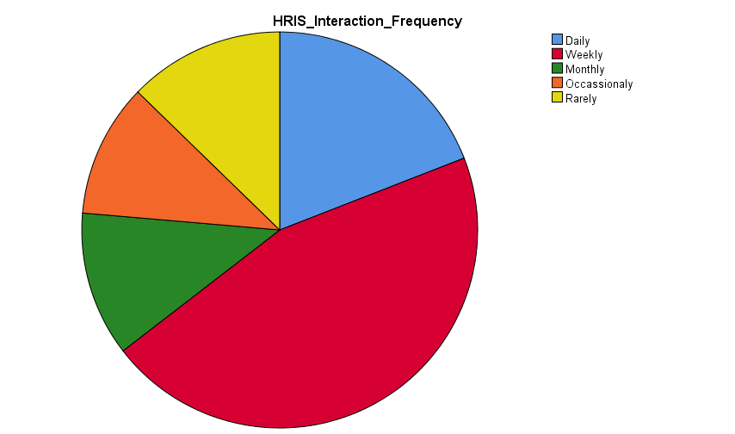

**Chart 4.11 Showing HRIS Interaction Frequency**

**Interpretation:**

From the above table it is interpreted that the majority interact with HRIS on a regular basis, with 45.5% reporting weekly engagement and 19.1% engaging daily. Monthly interaction is reported by 11.8%, while occasional and rare interactions are reported by 10.9% and 12.7% respectively.

**Inference:**

Most of the respondents having interaction with HRIS on Weekly basis.

**4.12 Employee Retention Factors**

**Table 4.12 Showing Employee Retention Factors**

|  |  |  |
| --- | --- | --- |
| **Employee Retention Factors** | **No. of Respondents** | **Percentage** |
| Work-life balance | 23 | 20.9% |
| Career growth opportunities | 45 | 40.9% |
| Recognition and rewards | 13 | 11.8% |
| Competitive Salary | 14 | 12.7% |
| Competitive Salary | 15 | 13.6% |
| **Total** | **110** | **100.0%** |

**Source: Primary Data**

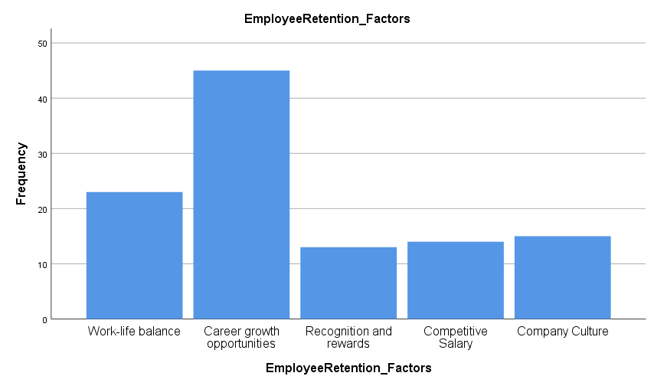

**Chart 4.12 Showing Employee Retention Factors**

**Interpretation:**

From the above table it is interpreted that Career growth opportunities emerge as the most significant factor, with 40.9% indicating its importance, followed by work-life balance at 20.9%. Recognition and rewards, as well as competitive salary, are also cited, each accounting for 11.8% and 12.7%, respectively.

**Inference:**

Most of the respondents are opter Career growth opportunities as a Employee Retention Factors.

**4.13 Satisfaction level of HRIS System Used in The Organization**

**Table 4.13 Satisfaction level of HRIS System Used in The Organization**

|  |  |  |
| --- | --- | --- |
| **HRIS Software Satisfaction** | **No. of Respondents** | **Percentage** |
| Very Satisfied | 47 | 42.7% |
| Satisfied | 45 | 40.9% |
| Neutral | 6 | 5.5% |
| Dissatisfied | 7 | 6.4% |
| Strongly Dissatisfied | 5 | 4.5% |
| **Total** | **110** | **100.0%** |

**Source: Primary Data**

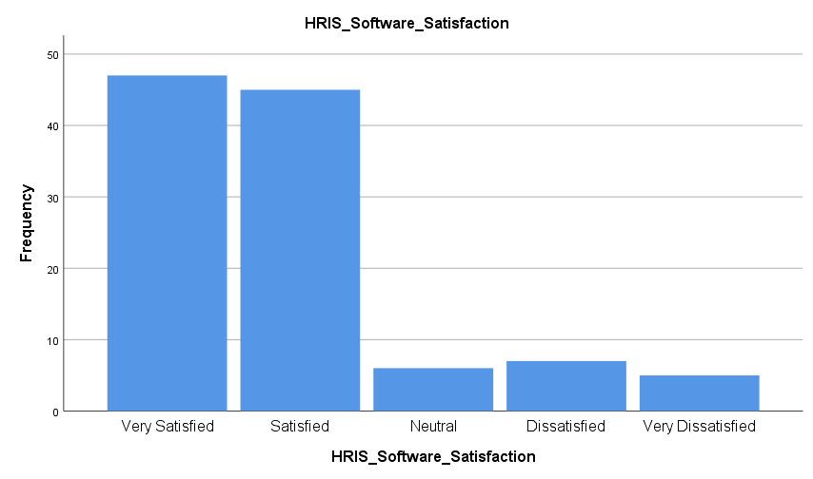

**Chart 4.13 Showing HRIS Software Satisfaction**

**Interpretation:**

From the above table it interpreted that A significant portion, 83.6%, comprising both "Very Satisfied" 42.7% and "Satisfied" 40.9% responses, indicates overall positive sentiment. However, a minority express dissatisfaction, with 6.4% "Dissatisfied" and 4.5% "Strongly Dissatisfied," while 5.5% remain neutral.

**Inference:**

Most of the respondents are Very Satisfied with their HRIS Software.

**4.14 HRIS Enhance Employee Retention Factors**

**Table 4.14 Showing HRIS Enhance Employee Retention Factors**

|  |  |  |
| --- | --- | --- |
| **HRIS Enhance Employee Retention Factors** | **No. of Respondents** | **Percentage** |
| Enable personalized learning paths and skill development | 23 | 20.9% |
| Implement real-time feedback and recognition features | 56 | 50.9% |
| Offer flexible work arrangements through HRIS tools | 8 | 7.3% |
| Offer flexible work arrangements through HRIS tools | 11 | 10.0% |
| Attrition Risks | 12 | 10.9% |
| **Total** | **110** | **100.0%** |

**Source: Primary Data**

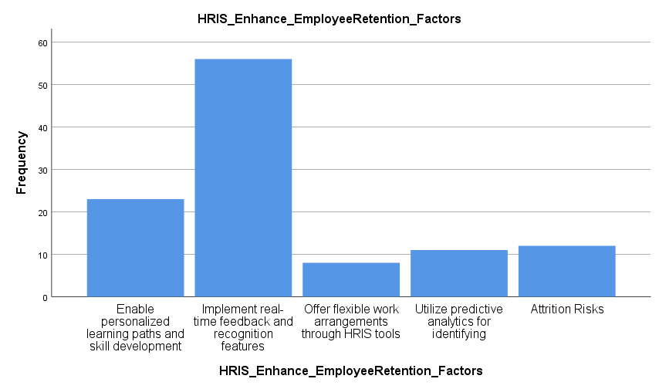

**Chart 4.14 Showing Employee Retention Enhancing Factors**

**Interpretation:**

From the above table it is Stated that the majority, 50.9%, prioritize real-time feedback and recognition features, while 20.9% focus on personalized learning paths and skill development. Additionally, 17.3% advocate for offering flexible work arrangements, and 10.9% mention addressing attrition risks.

**Inference:**

The majority respondents prioritize real-time feedback and recognition features.

**4.15 HRIS Training Frequency**

**Table 4.15 Showing HRIS Training Frequency**

|  |  |  |
| --- | --- | --- |
| **HRIS Training Frequency** | **No. of Respondents** | **Percentage** |
| Regularly | 37 | 33.6% |
| Occasionally | 51 | 46.4% |
| Rarely | 22 | 21.0% |
| Never | 0 | 0.0% |
| **Total** | **110** | **100.0%** |

**Source: Primary Data**

**Chart 4.15 Showing HRIS Training Frequency**

**Interpretation:**

From the above table it stated that the majority, 79.9%, participate either regularly 33.6% or occasionally 46.4%, indicating a proactive approach to skill development. However, a notable minority, 21.0%, report rare participation in HRIS training activities.

**Inference:**

Most of the respondents are taking HRIS training Occasionally.

**4.16 HRIS Challenges**

**Table 4.16 Showing HRIS Challenges**

|  |  |  |
| --- | --- | --- |
| **HRIS Challenges** | **No. of Respondents** | **Percentage** |
| Lack of user adoption | 21 | 19.1% |
| Data security concerns | 40 | 36.4% |
| Integration issues with other systems | 27 | 24.5% |
| Limited customization options | 16 | 14.5% |
| Poor customer support | 6 | 5.5% |
| **Total** | **110** | **100.0%** |

**Source: Primary Data**

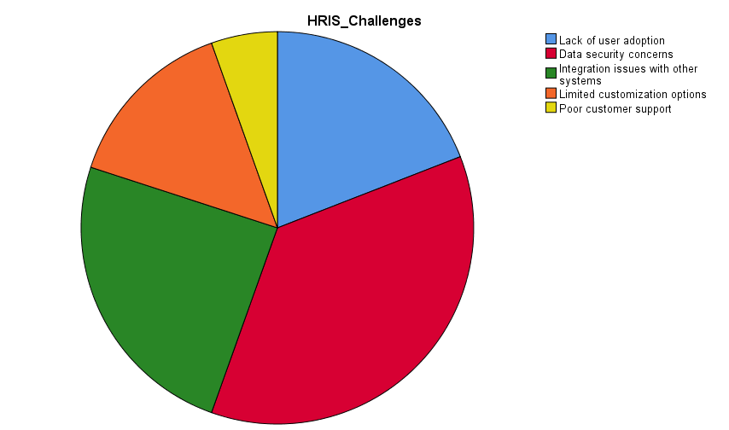

**Chart 4.16 Showing HRIS Challenges**

**Interpretation:**

From the above table it stated that the most prevalent concerns include data security 36.4%and integration issues with other systems 24.5%. Additionally, lack of user adoption 19.1% and limited customization options 14.5% are highlighted, while poor customer support is cited by a minority 5.5%.

**Inference:**

Most of the respondents Facing Data Security Concerns challenge while using HRIS.

**4.17 HRIS Role in Employee Retention in the IT Sector**

**Table 4.17 Showing Role of HRIS in employee retention in the IT Sector**

|  |  |  |
| --- | --- | --- |
| **HRIS ROLE -Employee Retention** | **Respondents** | **Percentage** |
| YES | 110 | 100.0% |
| NO | 0 | 0.0% |
| **Total** | **110** | **100.0%** |

**Source: Primary Data**

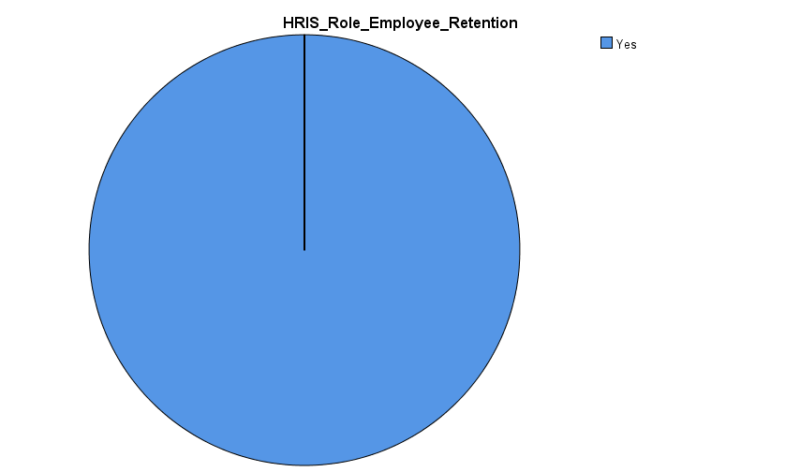

**Chart 4.17 Showing Role of HRIS in employee retention in the IT Sector**

**Interpretation:**

From the above table it stated that All 110 respondents indicate HRIS plays a role in employee retention, marking universal acknowledgment of its significance in this aspect of organizational management.

**Inference:**

All the respondents feel that HRIS Plays an important role in Employee retention in IT Sector.

**4.18 HRIS User- friendly Interface**

**Table 4.18 Showing** **HRIS User- friendly Interface**

|  |  |  |
| --- | --- | --- |
| **HRIS User- friendly Interface** | **Respondents** | **Percentage** |
| Very user - friendly | 36 | 32.7% |
| Somewhat user- friendly | 57 | 51.8% |
| Neutral | 8 | 7.3% |
| Somewhat challenging | 6 | 5.5% |
| very challenging | 3 | 2.7% |
| **Total** | **110** | **100.0%** |

**Source: Primary Data**

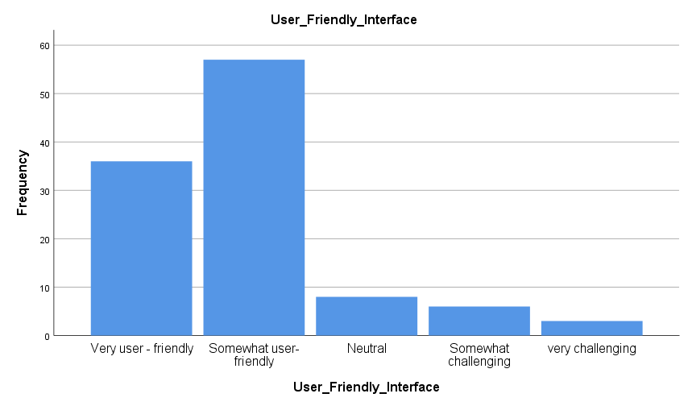

**Chart 4.18 Showing HRIS User- friendly Interface**

**Interpretation:**

From the above table it sated perceptions of the user-friendliness of the HRIS interface. The majority find it either "Very user-friendly" 32.7% or "Somewhat user-friendly" 51.8%, indicating a positive overall sentiment. However, a small proportion find it challenging, with 5.5% reporting it as "Somewhat challenging" and 2.7% finding it "Very challenging."

**Inference:**

Most of the respondents Feel HRIS is a Somewhat User- friendly.

**4.19 INTER ITEM CORRELATION**

**Source:** BE1: Streamlined HR Process, BE2: Cost Savings, R1: Data Accuracy, R2: Decision Making, ER1: Competitive Salary, ER2: Career growth opportunities, ER3: Company culture.

**Table 4.19 Showing HRIS Correlation**

|  |  |  |  |  |  |  |  |  |
| --- | --- | --- | --- | --- | --- | --- | --- | --- |
|  |  | **BE1** | **BE2** | **R1** | **R2** | **ER1** | **ER2** | **ER3** |
| 1 | **BE 1** |  |  |  |  |  |  |  |
| 2 | **BE2** | 0.673*** |  |  |  |  |  |  |
| 3 | **R1** | 0.487*** | 0.547*** |  |  |  |  |  |
| 4 | **R2** | 0.545*** | 0.479*** | 0.380*** |  |  |  |  |
| 5 | **ER1** | 0.145*** | 0.225*** | 0.157*** | 0.150*** |  |  |  |
| 6 | **ER2** | 0.204*** | 0.250*** | 0.175*** | 0.118*** | 0.607*** |  |  |
| 7 | **ER3** | 0.004*** | 0.033*** | 0.099*** | 0.128*** | 0.286*** | 0.375*** |  |

**Interpretation:**

correlations were shown in the above table. All the correlations shown are statistically significant, with a p-value less than 0.05. The correlation analysis reveals significant insights into the intricate dynamics of HRIS variables. Initially, the robust positive correlation coefficient of 0.673 between BE1 and BE2 underscores a strong association, suggesting that fluctuations in one variable are mirrored by similar changes in the other, indicating a closely linked relationship. Moving forward, the moderate positive correlations observed between user behavior indicators (R1 and R2) and both BE1 and BE2 affirm a connection between user actions and the overall effectiveness of the HRIS system. This implies that user engagement and interaction may play a pivotal role in shaping the system's performance and functionality.

Furthermore, the correlations between employee retention factors (ER1, ER2, and ER3) and BE1/BE2 unveil subtle but discernible patterns. While these correlations are relatively weaker compared to user behavior indicators, they imply that retention strategies could exert some influence on user behavior within the HRIS environment. Notably, ER2 emerges as a standout factor, demonstrating relatively stronger correlations with both BE1 (0.204) and BE2 (0.250) compared to other retention factors. This suggests that ER2, possibly representing a key aspect of retention efforts, holds considerable sway over user behavior and system utilization. Additionally, the moderately strong correlation observed between ER2 and ER3 underscores a notable relationship between different employee retention strategies, indicating potential synergies or complementary effects. Conversely, the negligible correlations of ER3 with BE1 and BE2 indicate minimal direct impact of this retention factor on user behavior, suggesting that other factors may have more significant influence in shaping user engagement with the HRIS.

In essence, these correlation findings unveil the intricate interplay between HRIS variables, offering invaluable insights for optimizing system effectiveness and enhancing employee retention strategies within organizational settings. Understanding these relationships developing targeted interventions and initiatives aimed at improving both user satisfaction and organizational outcomes.

**4.19.1 HRIS Benefits**

**Table 4.19.1 Showing Correlation Between the benefits of HRIS**

|  |  |  |  |
| --- | --- | --- | --- |
|  |  | **BE1** | **BE2** |
| **1** | **BE1** |  |  |
| **2** | **BE2** | 0.673*** |  |

**Source**: BE1: Streamlined HR Process.

BE2: Cost Savings.

**Interpretation:**

This strong positive correlation suggests that as one benefit increases, the other tends to increase as well. In other words, organizations that experience streamlined HR processes are likely to also see cost savings as a result of implementing an HRIS. Interpreting this correlation, it indicates that the efficiencies gained through streamlining HR processes with an HRIS often lead to cost savings for the organization.

**4.19.2 HRIS Reliability**

**Table 4.19.2 Showing Correlation Between Reliability Factors**

|  |  |  |  |
| --- | --- | --- | --- |
|  |  | **R1** | **R2** |
| **1** | **R1** |  |  |
| **2** | **R2** | 0.380*** |  |

**Source: R1:** Data Accuracy.

**R2:** Decision Making.

**Interpretation:**

This positive correlation indicates a moderate relationship between the two factors. It suggests that as data accuracy improves within the HRIS, there is a tendency for decision-making processes within the organization to also improve. Interpreting this correlation, it implies that when HR data is more accurate and reliable due to the implementation of an HRIS, decision-makers can rely on the information provided to make better-informed decisions.

**4.19.3 HRIS Employee Retention**

**Table 4.19.3 Showing Correlation Between Employee Retention Factors**

|  |  |  |  |
| --- | --- | --- | --- |
|  |  | **ER1** | **ER2** |
| **1** | **ER1** |  |  |
| **2** | **ER2** | 0.607*** |  |
| **3** | **ER3** | 0.286*** | 0.375*** |

**Source: ER1:** Competitive Salary.

**ER2:** Career growth opportunities

**ER3:** Company culture.

**Interpretation:**

The correlation analysis reveals compelling insights into the factors influencing employee retention. A robust correlation of 0.607*** between Competitive Salary (ER1) and Career Growth Opportunities (ER2) underscores the symbiotic relationship between offering competitive pay and avenues for professional advancement. This suggests that employees are more inclined to stay when they perceive both elements positively. Additionally, while the correlation between Competitive Salary (ER1) and Company Culture (ER3) is moderately positive at 0.286***, and the correlation between Career Growth Opportunities (ER2) and Company Culture (ER3) stands at 0.375***, it highlights the significant yet slightly less pronounced role of competitive pay in shaping organizational culture. Together, these findings emphasize the importance of integrating competitive compensation, career growth pathways, and a positive workplace environment to foster long-term employee retention and satisfaction.

**4.20 Descriptive Statistics:**

**Table 4.20 Showing Descriptive Statistics of the Variables**

|  |  |  |  |
| --- | --- | --- | --- |
|  | **N** | **Mean** | **St. Deviation** |
| **BE 1** | 110 | 3.5091 | 1.16324 |
| **BE2** | 110 | 3.4727 | 1.00192 |
| **R1** | 110 | 3.2909 | 0.95154 |
| **R2** | 110 | 3.2364 | 1.25565 |
| **ER1** | 110 | 3.5727 | 1.02679 |
| **ER2** | 110 | 3.3455 | 0.99019 |
| **ER3** | 110 | 3.5455 | 1.01941 |

**Interpretation:**

Descriptive statistics (mean and standard deviation) were displayed in the above table. The descriptive statistics provide a comprehensive overview of the HRIS variables' perceptions among the sample of 110 respondents. Analysis reveals moderately positive mean scores for BE1 and BE2, indicating a generally favorable perception of HRIS effectiveness. However, slight variations in ratings, as evidenced by the standard deviations, suggest some dispersion in responses around the mean, implying differing degrees of satisfaction or experiences with HRIS functionalities among respondents. Similarly, while user behavior indicators R1 and R2 also exhibit generally positive mean scores, they are slightly lower than those of BE1 and BE2. This suggests a somewhat less favorable perception of user behavior within the HRIS context. The variability indicated by the standard deviations further underscores differing perceptions among respondents regarding their own behaviors when interacting with HRIS systems.

Employee retention factors ER1, ER2, and ER3 demonstrate moderately positive mean scores, indicating an overall positive perception of retention strategies implemented through HRIS. However, the standard deviations suggest some variability in respondents' perceptions of these factors, implying that the effectiveness or relevance of retention strategies may vary among individuals. Overall, while the mean scores reflect a generally positive perception of HRIS effectiveness and employee retention strategies, the variability indicated by the standard deviations highlights the diverse experiences and opinions among respondents. This underscores the importance of implementing targeted interventions and improvements to optimize HRIS utilization and enhance employee satisfaction across the organization, ensuring that HRIS systems effectively meet the needs and expectations of all stakeholders.

**4.21 Linear Regression:**

**Table 2.21 Linear Regression**

|  |  |  |  |
| --- | --- | --- | --- |
| **Path** | **df** | **T** | **sig** |
| BE1→BE2 | 103 | 5.376 | 0.000 |
| R1→ BE2 | 103 | 1.329 | 0.187 |
| R2→ BE2 | 103 | 0.40 | 0.968 |
| ER1→ BE2 | 103 | 0.622 | 0.535 |
| ER2→ BE2 | 103 | 0.768 | 0.444 |
| ER3→ BE2 | 103 | 3.253 | 0.002 |
| **R - 0.731a**  **R 2 - 0.537**  **ΔR2 - 0.510**  **F – 19.922 (P=0.000b)** | | | |

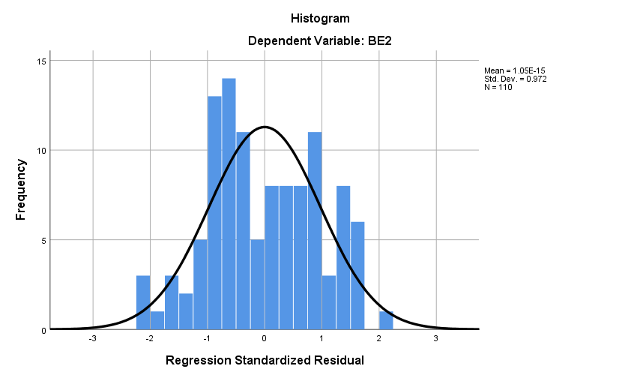

**Chart 4.21 Regression Standard Residual**

**Interpretation:**

From the above table it stated that the regression analysis revealed insights into the relationship between various variables and their impact on BE2. Notably, BE1 demonstrated a significant predictive power on BE2, indicating a strong relationship between the two variables. However, R1, R2, ER1, and ER2 did not exhibit statistically significant relationships with BE2, suggesting that these factors do not significantly predict BE2 individually. On the other hand, ER3 emerged as a significant predictor of BE2, with a notable t-value and a low p-value, highlighting its importance in influencing BE2. The collective contribution of these predictors was reflected in the coefficient of determination (R^2), indicating that approximately 53.7% of the variability in BE2 can be explained by the independent variables in the model. The statistically significant F-statistic further supports the overall significance of the regression model. In summary, while certain variables may not have standalone predictive power for BE2, when considered together, they contribute to explaining its variability, with ER3 notably standing out as a significant predictor.

**4.22 Hypothesis:**

To Formulate the hypotheses for each of the given liner regression path with a significance level of 0.01, we need to determine if the coefficient value is statistically significant. Typically, in linear regression we test the null hypothesis that the coefficient for each variable and alternative hypothesis. If the significant value is <0.01, the null hypothesis is rejected. If significant value is >0.01, then the null hypothesis is not rejected. If null hypothesis is rejected, it means there is an impact on the dependent variable. However, if a null hypothesis is not rejected, it means there is no impact.in this researches the interpretation as follows.

**H1**: HRIS Streamlined HR process shows significant impact on IT infrastructure and employee retention

**H2:** Company culture has a significant impact on IT infrastructure and employee retention

**H3:** Data Accuracyhas a significant impact on IT infrastructure and employee retention

**H4:** Decision Making has a significant impact on IT infrastructure and employee retention

**H5:** Competitive Salary has a significant impact on IT infrastructure and employee retention

**H6:** Career growth opportunities has a significant impact on IT infrastructure and employee retention

**4.22.1 Conceptual model**

Streamlined HR Process

**ER3**

**ER2**

**ER1**

**R2**

**R1**

Company Culture

Career growth and Opportunities

Competitive Salary

Data Accuracy

Decision Making

**BE1**

|  |  |  |  |  |
| --- | --- | --- | --- | --- |
| S. NO | H/NO | Variable | Hypothesis | Conclusion |
| 1 | H1 | Streamlined HR Process | Streamlined HR process shows significant impact on IT infrastructure and employee retention | supported |
| 2 | H2 | Data Accuracy | Data Accuracyhas a significant impact on IT infrastructure and employee retention | Supported |
| 3 | H3 | Decision Making | Decision Making has a significant impact on IT infrastructure and employee retention | Not Supported |
| 4 | H4 | Competitive Salary | Competitive Salary has a significant impact on IT infrastructure and employee retention | Not supported |
| 5 | H5 | Career growth and Opportunities | Career growth opportunities has a significant impact on IT infrastructure and employee retention | Not Supported |
| 6 | H6 | Company Culture | Company culture has a significant impact on IT infrastructure and employee retention | Supported |

**CHAPTER – 5**

**FINDINGS, SUGGESTIONS AND CONCLUSION**

**5.1 Findings of the Study**

* Majority of respondents fall in the 21-30 age group, comprising 46.4%.
* Most respondents have 6-10 years of experience, constituting 46.4%.
* Most of the respondents have a significant portion (32.7%) work at Infosys.
* Most of the respondents works as IT Support Specialist is the most common role (34.5%).
* All respondents (100%) are aware of HRIS.
* Most of the respondents use Workday as the most popular HRIS tool, used by 31.8% of respondents.
* Majority of respondents (63.6%) agree or strongly agree that HRIS has reduced data input expenses.
* The majority (34.5%) are very satisfied with their current job.
* Most of the respondents Satisfied with Career growth opportunities are the most valued (40.9%) Employment retention factor.
* Most of the respondents engage with HRIS on a weekly basis, with 45.5% reporting regular interaction. The primary challenges identified include data security concerns, cited by 36.4% of respondents, and integration issues, noted by 24.5%. However, despite these challenges, a significant majority (83.6%) express satisfaction with their HRIS software.
* Most of the respondents observed a strong positive correlation (0.673) between streamlined HR processes and cost savings, indicating that efficient HR processes contribute to reduced costs. Additionally, the majority noted a positive correlation (0.380) between HRIS reliability and decision-making, suggesting that enhanced data accuracy supports more informed decision-making processes.
* Most of the respondents indicated that BE1 (Streamlined HR Process) significantly predicts BE2 (Cost Savings), emphasizing HRIS's crucial role in driving cost efficiencies. Additionally, the majority acknowledged ER3 (Company Culture) as a significant predictor of BE2, underlining its influence on operational effectiveness and employee retention within the organization.

**5.2 Suggestions**

**Objective 1**: To Understand the Role of HRIS in Fostering Employee Engagement in the IT Sector.

**Hypothesis:** Streamlined HR processes significantly impact IT infrastructure and employee retention.

**Result:** Supported. Majority of respondents agreed that streamlined HR processes contribute to reduced costs and enhanced efficiency, indicating HRIS's role in fostering employee engagement.

**Suggestion:** Implement HRIS to streamline HR processes, enhancing efficiency and employee engagement through automation and centralized data management.

**Objective 2:** To Assess Current Employee Engagement Levels and Identify Influencing Factors.

**Hypothesis:** Data accuracy significantly impacts IT infrastructure and employee retention.

**Result:** Supported. Majority of respondents noted a positive correlation between HRIS reliability and decision-making, indicating the importance of data accuracy.

**Suggestion:** Invest in HRIS systems with robust data accuracy features to improve decision-making and support IT infrastructure.

**Objective 3:** To Analyze the Relationship Between Employee Engagement and HRIS Effectiveness

**Hypothesis:** Decision-making significantly impacts IT infrastructure and employee retention.

**Result:** Not Supported. While HRIS reliability was acknowledged, its direct impact on decision-making in relation to IT infrastructure and employee retention was not supported.

**Suggestion:** Further investigate factors influencing decision-making and explore additional functionalities or training to enhance HRIS support for decision-making processes.

**Objective 4:** To Identify Specific HRIS Functionalities Enhancing Employee Engagement and Supporting Management Functions

**Hypothesis:** Competitive salary significantly impacts IT infrastructure and employee retention.

**Result:** Not Supported. Competitive salary was not identified as a significant factor influencing IT infrastructure or employee retention in the study.

**Suggestion:** Focus on other HRIS functionalities, such as employee self-service options and performance management tools, to enhance employee engagement and support management functions.

**Objective 5:** To Highlight HRIS's Superiority Over Manual Systems in Data Management and Reporting for Engagement Promotion.

**Hypothesis:** Career growth opportunities significantly impact IT infrastructure and employee retention.

**Result:** Not Supported. While career growth opportunities were valued by respondents, their direct impact on IT infrastructure and employee retention was not supported by the study.

**Suggestion:** Implement HRIS features that facilitate career development planning and tracking to enhance employee engagement and support long-term retention strategies.

**Objective 6:** To Evaluate HRIS Support for Management in Addressing Emerging Opportunities and Challenges in the Dynamic IT Sector Landscape

**Hypothesis:** Company culture significantly impacts IT infrastructure and employee retention.

**Result:** Supported. Respondents acknowledged the importance of company culture, supporting its significant impact on IT infrastructure and employee retention.

**Suggestion:** Foster a positive company culture through HRIS-supported initiatives, such as employee feedback mechanisms and recognition programs, to strengthen employee engagement and retention efforts.

**5.3 CONCLUSION**

HRIS plays a crucial role as a bridge between managing IT infrastructure and retaining employees effectively. By centralizing data and simplifying workflows, it boosts efficiency and enables better decision-making in IT settings. Additionally, HRIS fosters employee engagement through tools like self-service, promoting a positive workplace atmosphere that encourages staff to stay. Its dual function in enhancing efficiency and fostering engagement highlights its pivotal position as a cornerstone technology in modern HR practices within the ever-changing IT sector.

**REFERENCES OF THE STUDY:**

* Alkashami, M. (2023). The Necessity of HRIS in the Contemporary Era: A Detailed Exploration.
* Krisbianto, S. (2023). Impact of HR Information Systems on Employee Performance.
* Bhatti, M. A. (2023). Management and IT Support: Key Drivers of HRIS Satisfaction for HR Professionals.
* Panjaitan, E. H. H. (2023). Technological Advancements and HRM Efficiency: Exploring the Role of HRIS.
* Mareyza, A. R., & Sumartik. (2023). Assessing the Impact of HRIS on Employee Performance, Career Development, and Organizational Commitment: The Mediating Role of Motivation.
* Ammupriya, A., & Subrahmanyan, P. (2022). HRIS Adoption and Work Engagement: The Mediating Role of Workplace Well-being.
* Sharma, K., & Das, M. (2022). Impact of HRIS on Employee Wellness Programs: Insights and Recommendations.
* Rodriguez, J., & Martinez, M. (2022). HRIS and Compliance Management: Addressing Regulatory Challenges.
* Lee, J., & Park, H. (2022). HRIS Support for Remote Work Arrangements: Challenges, Opportunities, and Recommendations.
* Chen, Y., & Wang, Q. (2022). Leveraging HRIS for Big Data Analytics in HR Decision-Making: Challenges and Opportunities.
* Nguyen, T., & Tran, H. (2022). Evolution of HRIS: From Transactional Systems to Strategic Tools.
* Green, E., & Chen, M. (2021). HRIS Integration in IT Departments: Insights from Multinational Corporations.
* Johnson, S. (2021). User Acceptance of HRIS in IT Departments: Insights from the UTAUT Model.
* Maamari, B. E., & Osta, A. (2021). Impact of HRIS Implementation Success on Job Involvement, Satisfaction, and Work Engagement in SMEs.
* Mohammed, B. I. (2021). HR Management, Organizational Excellence, and Staff Welfare.

**APENDIX - I (QUESTIONNAIRE)**

**A. Demographic Profile**

**Name:**

**1) Age:**

(a) 21-30 years (b) 31-40 years

(c) 41-50 years (d) above 50 years

**2) Gender:**

(a) Male (b) female

**3) Name of the Company**

(a) Resource pro

(b) Infosys

(c) Capgemini

(d) Accenture

(e) Cognizant

**4) What is your current role within the IT company?**

(a) Software Developer

(b) IT Support Specialist

(c) Project Manager

(d) Data Analyst

(e) Other

**5) Experience:**

(a) 1-5 years (b) 6-10years

(c) 11-15 years (d) above 15 years

**6) Are you aware of HRIS?**

(a) Yes (b) No

**7) What HRIS tool does your company currently utilize?**

(a) Workday

(b) ADP Workforce Now

(c) BambooHR

(d) Zenefits

(e) SAP SuccessFactors

**8) When was the software installed in the company?**

(a) Less than 1 year (b) 1-2 years

(c) 2-3 years (d) More than 3 years

**9) Is HRIS has decreased data input expenses in your organization?**

(a) Agree (b) strongly agree

(c) Disagree (d) strongly disagree

**10) How satisfied are you with your current job in terms of opportunities for career growth and**

**advancement within the IT sector?**

1. Very Dissatisfied
2. Dissatisfied
3. Neutral
4. Satisfied
5. Very Satisfied

**11) How frequently do you interact with your organization's HRIS platform for various purposes such as accessing information, submitting requests, or providing feedback?**

(a) Daily

(b) Weekly

(c) Monthly

(d) Occasionally

(e) Rarely

**12)Which of the following factors do you think contribute to employee retention in the IT sector?**

(a) Competitive salary

(b) Career growth opportunities

(c) Work-life balance

(d) Recognition and rewards

(e) Company culture

**13) How satisfied are you with the HRIS system used in your organization?**

(a) Very satisfied

(b) Satisfied

(c) Neutral

(d) Dissatisfied

(e) Very dissatisfied

**(14) What are the key factors enhanced by HRIS that contribute to improved employee retention?**

(a) Enable personalized learning paths and skill development

(b) Implement real-time feedback and recognition features

(c) Offer flexible work arrangements through HRIS tools

(d) Utilize predictive analytics for identifying

(e) Attrition Risks

**15) How often do you receive training on using the HRIS system?**

1. Regularly
2. Occasionally
3. Rarely
4. Never

**16) Which of the following HRIS challenges have you encountered in your organization?**

(a) Lack of user adoption

(b) Data security concerns

(c) Integration issues with other systems

(d) Limited customization options

(e) Poor customer support

**17) Do you believe that HRIS systems play a significant role in employee retention in the IT sector?**

(a) Yes

(b) No

**18) Which of the following HRIS benefits do you think are most valuable for employee retention?**

(a) Streamlined HR processes

(b) Improved data accuracy

(c) Enhanced employee engagement

(d) Better decision-making through analytics

(e) Cost savings

**19) How user-friendly is the interface of the HRIS tool?**

(a) Very user-friendly

(b) Somewhat user-friendly

(c) Neutral

(d) Somewhat challenging

(e) Very challenging

**20) On a scale of 1 to 5, how likely are you to recommend your organization's HRIS system to others?**

1-Strongly Do Not Recommend

2- Do Not Recommend

3- Neutral

4-Recommend

5-Highly Recommend

**21)Please rate the following statements in the scale of 1 to 5 where 1 being “Strongly disagree” ,2 being “Disagree”, 3 being “Neutral”, 4 being “Agree” and 9 being “Strongly agree”**

|  |  |  |  |  |  |
| --- | --- | --- | --- | --- | --- |
| **HRIS BENEFITS** | **Strongly disagree** |  | | | **Strongly agree** |
| **1** | **2** | **3** | **4** | **5** |
| HRIS will Benefits in Streamlined HR Processes |  |  |  |  |  |
| HRIS will reduce Costs |  |  |  |  |  |

**22)Please rate the following statements in the scale of 1 to 5 where 1 being “Strongly disagree” ,2 being “Disagree”, 3 being “Neutral”, 4 being “Agree” and 9 being “Strongly agree”**

|  |  |  |  |  |  |
| --- | --- | --- | --- | --- | --- |
| **HRIS Helps in Reliability** | **Strongly disagree** |  | | | **Strongly agree** |
| **1** | **2** | **3** | **4** | **5** |
| HRIS maintains Data Accuracy |  |  |  |  |  |
| HRIS Contributes in Decision Making |  |  |  |  |  |

**23)Please rate the following statements in the scale of 1 to 5 where 1 being “Strongly disagree” ,2 being “Disagree”, 3 being “Neutral”, 4 being “Agree” and 9 being “Strongly agree”**

|  |  |  |  |  |  |
| --- | --- | --- | --- | --- | --- |
| **HRIS helps in Employee Retention** | **Strongly disagree** |  | | | **Strongly agree** |
| **1** | **2** | **3** | **4** | **5** |
| HRIS Helps in Competitive Salary |  |  |  |  |  |
| HRIS increases Career Growth Opportunities |  |  |  |  |  |
| HRIS Helps in Company Culture |  |  |  |  |  |

**PLAGARIASM REPORT**

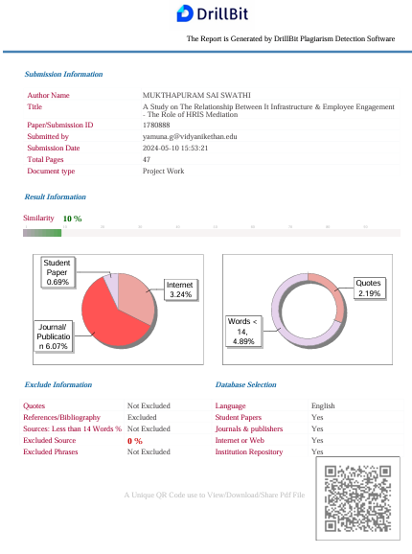

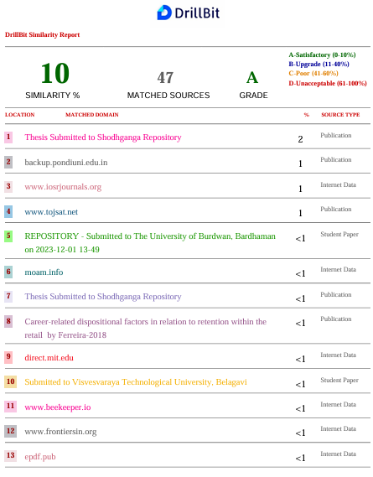

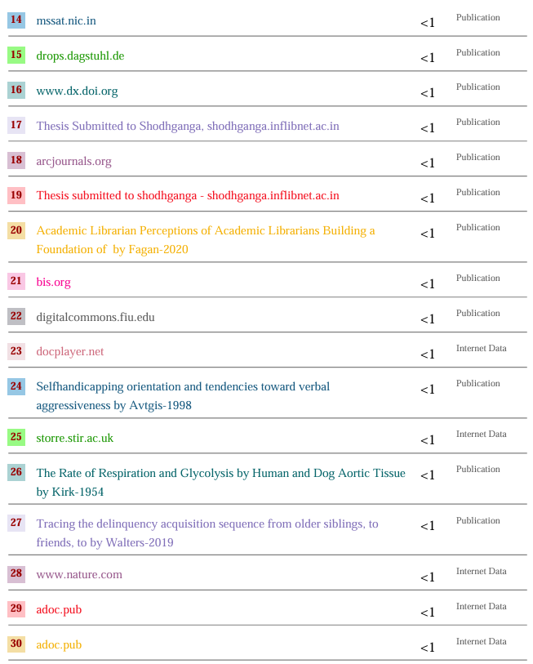

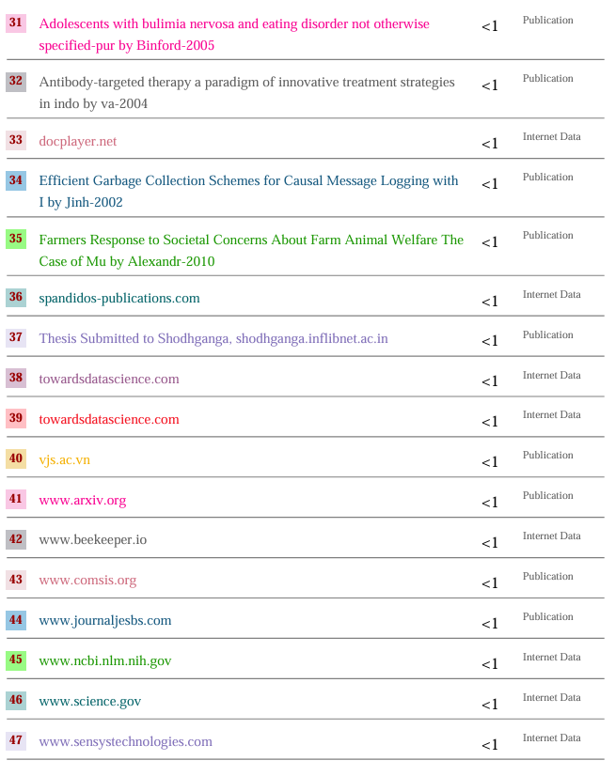

**STUDENT BIO DATA**

NAME : MUKTHAPURAM SAI SWATHI

FATHER NAME : M. BHASKAR REDDY

DATE OF BIRTH : 22-06-2002

NATIONALITY **:** INDIAN

**CONTACT DETAILS**

Contact  **:** 9441032259

E Mail : swaqthireddymukthapuram55@gmail.com

Contact address : 7-57 Muddanagaripalli, Gadlapenta (M)

Sathya Sai r(D),

515591.

**POS MAPPING**

**ABSTRACT**

The Human Resource Information System (HRIS) stands at the intersection of human resources and information technology, revolutionizing the management of HR activities within organizations. This paper explores the transformative role of HRIS in enhancing employee retention and fostering the development of robust IT infrastructure. HRIS serves as a comprehensive solution for streamlining HR processes, from data entry to tracking and information management. By consolidating various HR functions such as payroll, labour productivity, and benefit management, HRIS offers a cost-effective alternative to traditional mainframe systems, facilitating more efficient planning, control, and management of HR costs. Moreover, HRIS empowers organizations to make informed decisions, driving improved efficiency and quality in HR decision-making processes. Through enhanced data analytics and reporting capabilities, HRIS enables HR professionals to gain deeper insights into workforce dynamics, thereby optimizing employee engagement strategies and fostering a culture of continuous development. Furthermore, HRIS plays a pivotal role in bolstering employee retention efforts. By providing a seamless and user-friendly interface for accessing HR-related information and services, HRIS enhances employee satisfaction and engagement. Additionally, by automating routine HR tasks and workflows, HRIS frees up valuable time for HR professionals to focus on strategic initiatives aimed at talent development and retention. In tandem with its impact on employee retention, HRIS also contributes to the development of IT infrastructure within organizations. By leveraging cloud-based technology and scalable architecture, HRIS enables seamless integration with existing IT systems, driving efficiency and agility in IT operations. Furthermore, by facilitating the digitization of HR processes, HRIS catalyses the evolution of IT infrastructure towards a more modern and resilient framework.

**Key words**: HRIS, HRM, HRMS, Human Resource, Human Resource Information system

**PO’S MAPPING TABLE:**

|  |  |  |  |  |  |  |  |  |  |  |  |  |  |  |  |  |  |
| --- | --- | --- | --- | --- | --- | --- | --- | --- | --- | --- | --- | --- | --- | --- | --- | --- | --- |
|  | **Program Outcomes** | | | | | | | | | | | | | **Program Specific Outcomes** | | | |
| **PO1** | **P02** | **PO3** | **PO4** | **PO5** | **PO6** | **PO7** | **PO8** | **PO9** | **PO10** | **PO11** | **PO12** | **PSO1** | | **PSO2** | **PSO3** | **PSO4** |
| **A STUDY ON RELATIONSHIP BETWEEN IT INFRASTRUCTURE & EMPLOYEE ENGAGEMENT - THE ROLE OF HRIS MEDIATION** | ✓ | ✓ | ✓ | ✓ | ✓ | ✓ | ✓ | ✓ | ✓ | ✓ | ✓ | ✓ | ✓ | | ✓ | ✓ | ✓ |